RAINFALL PREDICTION

**1.INTRODUCTION:**

Our project is about rainfall prediction it predict the rainfall in each state for all the months form Jan to Dec. As global warming is increasing earths temperature due to which our local regions yearly rainfall patterns have been affecting This harms the farmers and other people who depend on rainfall Proper water supply keeps farm land in a good condition For this rainfall prediction there are many researches conducted using data mining and machine learning proper rainfall should be there to in correct way to prevent flooding, drought, landslides, mass movements and avalanches Timely and accurate forecasting can help reduce human and financial loss The main theme of this project is to study and identify atmosphere that cause rainfall and to the intensityIt describes the relationship between atmospheric variables that affect the rainfall Rainfall is a climate factor that affects many human activities like agricultural production construction,power generation,foresty and tourism A study is conducted and identified solar radiation,perceptible water vapor are important variables for daily rainfall prediction This is using data driven machine learning algorithm but it is better to use simple linear regression which has only one independent feature.

## 2.LITERATURE REVIEW

In previous research papers, we have observed that different machine learning algorithms have been used. Few papers are based on deep learning also. The field of Artificial Intelligence has been the suitable area to carry out all types of predictions on the dataset by extracting and data preprocessing. Logistic Regression, Support Vector Machine, Naïve Bayes Classification, Linear regression and ridge regression etc. are the various machine learning algorithms the have been used. We have observed that the algorithms work together by generating the pattern among the available dataset and proceeding with prediction. Mid Infrared Spectroscopy combined with few machine learning algorithms. Deep learning is something that works by generating biases and weights in the layers, rule based takes the bulk values and signifies a rule in it. SVM are used with algorithms especially which follows a close correlation among the variables taken into consideration. Artificial Neural Network inspired by the structure and function of the human brain. PLS regression stands for Partial Square regression, which is a statistical technique used for modelling the relationship between the two sets of variables. In PLS regression, both the predictor variables and the response variables are transformed into new sets of variables called latent variables, which are linear combination of the original variables. PLS regression is useful for predicting a response variable from a large number of predictor variables, even when these variables are highly correlated. It is commonly used in fields such as chemistry, biology, and engineering, where there are many variables to consider in modelling complex systems. It is also used in data analysis and machine learning to identify important variables and reduce dimensionality of the data

|  |  |  |  |  |
| --- | --- | --- | --- | --- |
| **Authors** | **Regio n** | **Techniqu**  **es** | **Rainfall predicting attribute** | **Accuracy measure** |
| *M.Kannan et al.* | *Global* | *Regression* | *Rainfall,humidity* | *MSE* |
| *S. Chattopadhyay* | *Global* | *ANN* | *Rainfall* | *MSE* |
| *P. Dutta, H. Tahbilder* | *Global* | *Regression* | *Rainfall* | *MSE* |
| *P. Goswami,*  *Srividya* | *Global* | *ANN* | *Mean rainfall* | *Relative percentag e error* |
| *S. Kannan, S. Ghosh* | *Local*  *(river)* | *Decision tree,*  *CART, Kmean* | *Rainfall,humidity* | *MSE* |
| *A. Naik* | *Global* | *Monthly* | *Wind,speed,temperature,humi dity* | *RMSE* |
| *S.nanda* | *Global* | *Yearly* | *Min_max temperature* | *MSE* |
| *R.Deshpande* | *Local* | *Monthly* | *Rainfall* | *MSE* |
| *G.shrivastava* | *Local* | *Yearly* | *Humidity,dew point,pressure* | *MSE* |
| *P.dutta,H.Tahbild er* | *Global* | *Monthly* | *Min-Max,temperature,wind direction,humidity,rainfall* | *RMSE* |

## 3.DATA SET DESCRIPTION

* This dataset contains 641number of rows and 19 columns each row has Indian state name ,district ,rainfall amount in cm/inches of each and every month from January to December
* As this dataset considered as supervised because it is labelled dataset to train algorithms that to classify data or predict outcomes accurately
* JAN
* FEB
* MAR
* APR
* MAY
* JUNE
* JUL
* AUG
* SEP
* OCT
* NOV
* DEC
* JAN-FEB
* MAR-MAY
* JUN-SEP

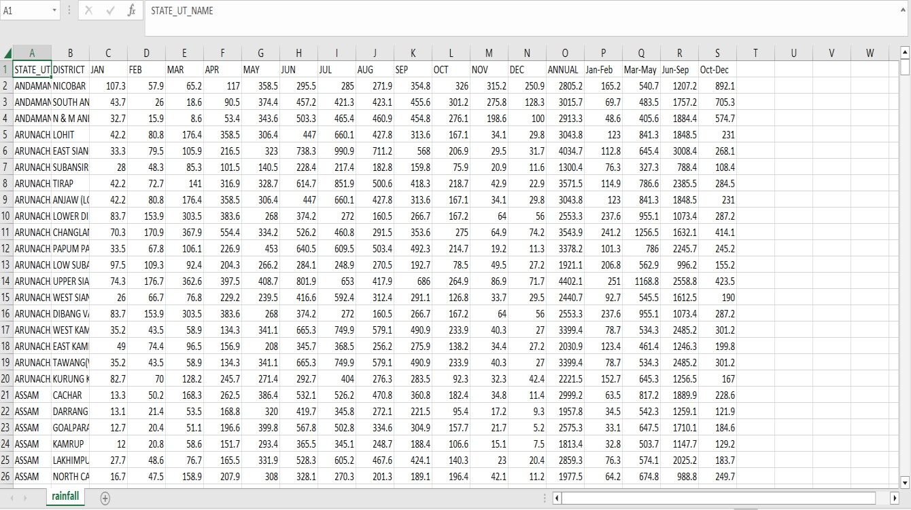

**4.DATA VISULAZATION:**

The following are plotting of each feature against the target.

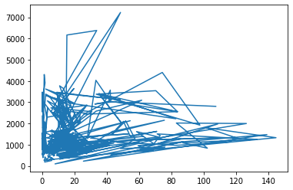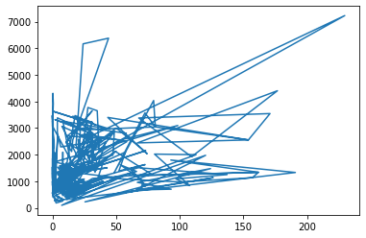

Jan vs annual feb

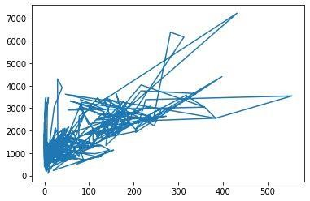 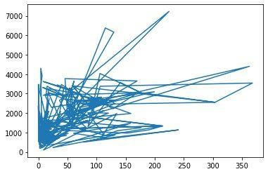

apr  mar

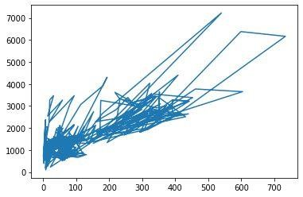 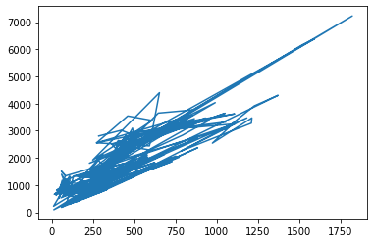

may june

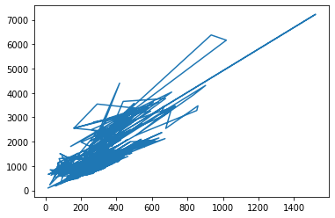 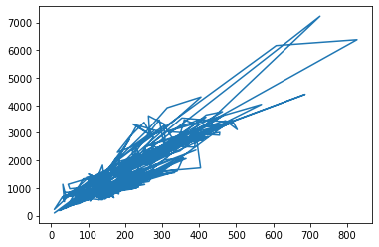

july august

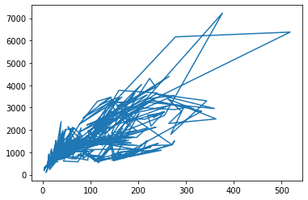 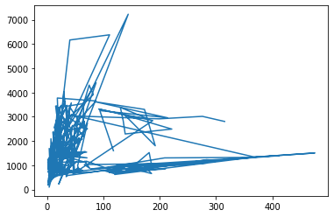

S eptember october

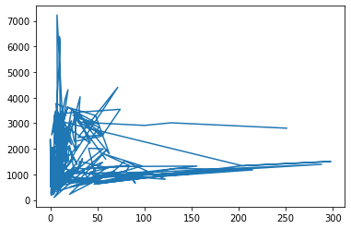 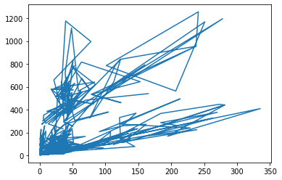

November December

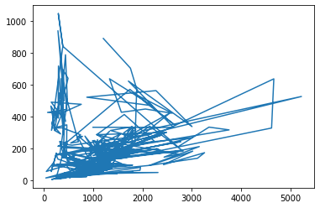 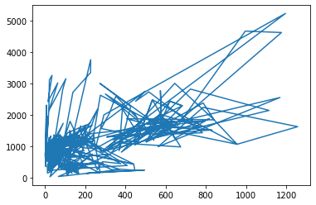

Jan-feb vs mar -may mar-may vs jun -sep

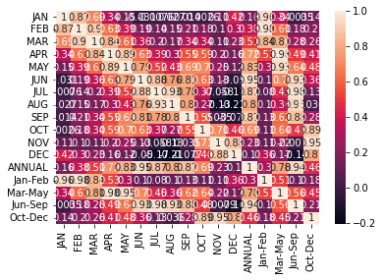 

# Co variance co relation

**5. METHODOLOGY**

## PROCEDURE TO SOLVE THE GIVEN PROBLEM

In this project Dogecoin price prediction and prediction, we use three approaches: •Linear regression

* K-Nearest Neighbour
* Support Vector Machine
* Decision Tree

**Linear regression:**

Linear regression is a supervised machine learning method that is used by the Train Using AutoML tool and finds a linear equation that best describes the correlation of the explanatory variables with the dependent variable. This is achieved by fitting a line to the data using least squares. The line tries to minimiz the sum of the squares of the residuals. The residual is the distance between the line and the actual value of the explanatory variable. Finding the line of best fit is an iterative process.

**Advantages of linear regression algorithm:**

* Linear regression performs exceptionally well for linearly separable data
* Easier to implement, interpret and efficient to train
* It handles overfitting pretty well using dimensionally reduction techniques, regularization, and cross-validation
* One more advantage is the extrapolation beyond a specific data set

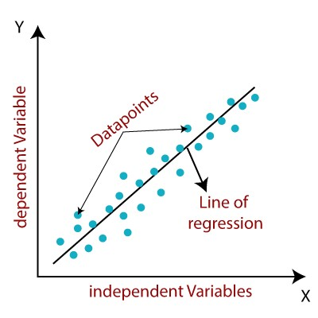

**K-Nearest Neighbour:**

The k-nearest neighbors algorithm, also known as KNN or k-NN, is a non-parametric, supervised learning classifier, which uses proximity to make classifications or predictions about the grouping of an individual data point.

While it can be used for either regression or classification problems, it is typically used as a classification algorithm, working off the assumption that similar points can be found near one another.

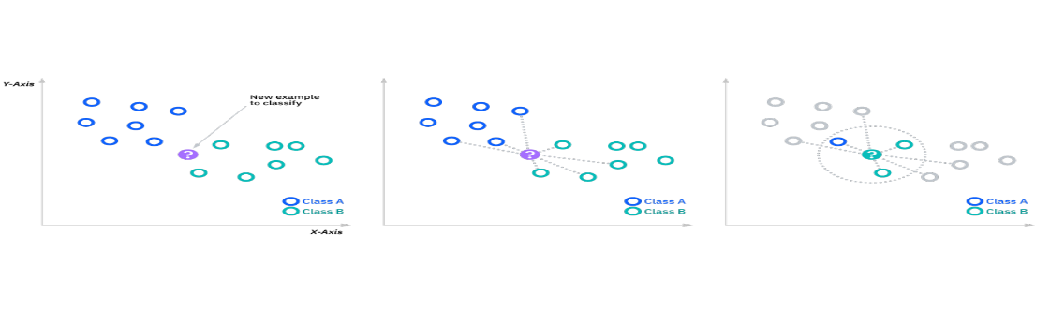

**KNN Formula:**

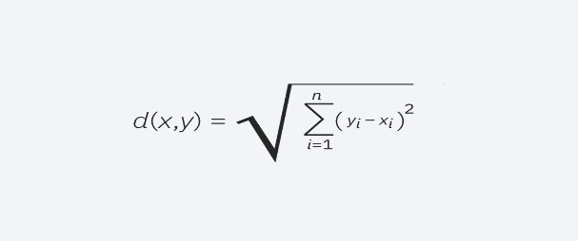

## Support Vector Machine

Support Vector Machine or SVM is one of the most popular Supervised Learning algorithms, which is used for Classification as well as Regression problems. However, primarily, it is used for Classification problems in Machine Learning.

The goal of the SVM algorithm is to create the best line or decision boundary that can segregate n-dimensional space into classes so that we can easily put the new data point in the correct category in the future. This best decision boundary is called a hyperplane.

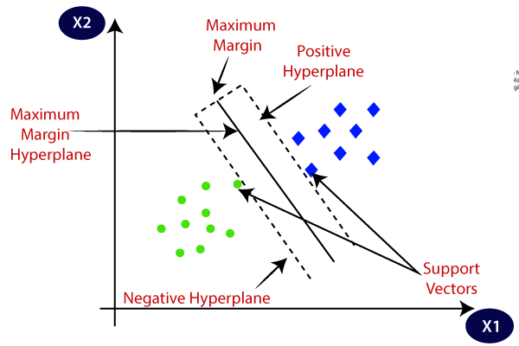

## Decision tree

Decision trees are a nonparametric supervised learning method used for classification and regression. The deeper the tree, the more complex the decision rules and the fitter the model. Decision tree uses the tree representation to solve the problem. In which each leaf node corresponds to a class label and attributes are represented on the internal node of the tree. The primary challenge in the decision tree implementation is to identify the attributes. There are two popular attribute selection measures they are Entropy and Gini index. Entropy is the measure of uncertainty of a random variable, it characterizes the impurity of an arbitrary collection of examples. The higher the entropy more the information content

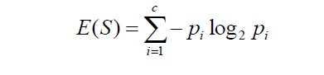

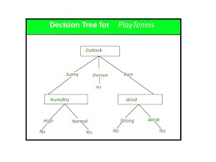

**6. MODEL ARCHITECTURE**

|  |
| --- |
| RAINFALL PREDICTION DATASET |

LOADING DATA SET

IDENTIFYING THE ATTRIBUTES

PERTAINING THE

# RAINFALL DATASET

|  |
| --- |
| COLLECTION OF DATA AND PRE -PROCESSING |

-

LINEAR REGRESSION, KNN, DECISION TREE,SVM

OBTAIN RESULTS

# CONCLUSION

**SOFTWARE DESCRIPTION**

**Software requirements:**

**Operating system:** Windows

**Platform**: google Collab

**Programing language:** python

**7. RESULTS**

## CODE

**Dataset:**

import pandas as pd

d=pd.read_csv(‘/content/rainfall prediction.csv’) print(d) **output:**

STATE_UT_NAME DISTRICT JAN FEB MAR APR \

1. ANDAMAN And NICOBAR ISLANDS NICOBAR 107.3 57.9 65.2 117.0
2. ANDAMAN And NICOBAR ISLANDS SOUTH ANDAMAN 43.7 26.0 18.6 90.5
3. ANDAMAN And NICOBAR ISLANDS N & M ANDAMAN 32.7 15.9 8.6 53.4
4. ARUNACHAL PRADESH LOHIT 42.2 80.8 176.4 358.5 4 ARUNACHAL PRADESH EAST SIANG 33.3 79.5 105.9 216.5

.. ... ... ... ... ... ...

1. KERALA IDUKKI 13.4 22.1 43.6 150.4
2. KERALA KASARGOD 2.3 1.0 8.4 46.9
3. KERALA PATHANAMTHITTA 19.8 45.2 73.9 184.9
4. KERALA WAYANAD 4.8 8.3 17.5 83.3
5. LAKSHADWEEP LAKSHADWEEP 20.8 14.7 11.8 48.9

MAY JUN JUL AUG SEP OCT NOV DEC ANNUAL Jan-Feb \

1. 358.5 295.5 285.0 271.9 354.8 326.0 315.2 250.9 2805.2 165.2
2. 374.4 457.2 421.3 423.1 455.6 301.2 275.8 128.3 3015.7 69.7
3. 343.6 503.3 465.4 460.9 454.8 276.1 198.6 100.0 2913.3 48.6
4. 306.4 447.0 660.1 427.8 313.6 167.1 34.1 29.8 3043.8 123.0
5. 323.0 738.3 990.9 711.2 568.0 206.9 29.5 31.7 4034.7 112.8

.. ... ... ... ... ... ... ... ... ... ...

1. 232.6 651.6 788.9 527.3 308.4 343.2 172.9 48.1 3302.5 35.5
2. 217.6 999.6 1108.5 636.3 263.1 234.9 84.6 18.4 3621.6 3.3
3. 294.7 556.9 539.9 352.7 266.2 359.4 213.5 51.3 2958.4 65.0
4. 174.6 698.1 1110.4 592.9 230.7 213.1 93.6 25.8 3253.1 13.1 640 171.7 330.2 287.7 217.5 163.1 157.1 117.7 58.8 1600.0 35.5

Mar-May Jun-Sep Oct-Dec

0 540.7 1207.2 892.1 1 483.5 1757.2 705.3

1. 405.6 1884.4 574.7
2. 841.3 1848.5 231.0
3. 645.4 3008.4 268.1

.. ... ... ...

1. 426.6 2276.2 564.2
2. 272.9 3007.5 337.9 638 553.5 1715.7 624.2
3. 275.4 2632.1 332.5
4. 232.4 998.5 333.6

[641 rows x 19 columns] **Linear regression:**

from sklearn.linear_model import LinearRegression lr=LinearRegression() mm=lr.fit(x_train,y_train) yp=mm.predict(x_test) print(yp) **output:**

[1233.9 1223.4 1327.9 1057.6 2641.8 646.5 961.1 1070.6 485.7 1122.9

1029.6 3470.6 1209.3 308.1 2958.4 498. 2814.4 1796.5 1068.5 646.1

2440.7 1973.9 1081.4 2859.3 1293.1 3468.3 898.2 992.9 1235.7 1535.5

3094.5 966.7 793.4 449.2 747.1 544. 1803.2 818. 508.1 3218.7

746.9 2480.6 839.2 1336.5 460.6 1533.5 6379.9 1003.3 837. 1087.7

2127.5 622.8 1123.6 685.6 1366.2 1680.7 1481.6 788.4 777. 2512.6

992.2 747.1 1336.5 388.8 863.6 2805.2 1416.2 708.4 1293.3 902.6

974.9 747.1 1474.3 613.9 449.4 700.4 2731.1 1921.1 807.8 2123.9

1528.2 655. 1091.6 1618.3 3302.5 572. 1146.8 1385.5 1148.6 1109.9

2374.1 886.1 2116.9 818.7 897.4 2098. 1005.6 419.5 714.4 1363.3

1448.3 936.2 1155.4 1062.7 871.5 720. 1008.4 455.6 1192.2 1191.5

2814.4 986.3 963.9 252.9 850.1 1229. 1104.7 301.6 1474.1 3399.4 1010.8 1504.4 1530.9 1392.7 1584.9 1462.1 692.7 2556.6 1206.7]

from sklearn.metrics import mean_squared_error print(mean_squared_error(yp,y_test)) **output:**

2.862281872213113e-25

from sklearn.metrics import mean_absolute_error print(mean_absolute_error(yp,y_test)) **output:**

3.615505827542091e-13

mse = mean_squared_error(y_test, yp) print("Mean Squared Error:", mse) **output:**

Mean Squared Error: 2.862281872213113e-25

mae = mean_absolute_error(y_test, yp) print("Mean Absolute Error:", mae) **output:**

Mean Absolute Error: 3.615505827542091e-13

**K-Nearest Neighbour:**

from sklearn.neighbors import KneighborsRegressor knn = KNeighborsRegressor(n_neighbors=3) knn.fit(x_train, y_train) y_pred = knn.predict(x_test)

mae = mean_absolute_error(y_test, y_pred) print("Mean Absolute Error:", mae) **output:**

Mean Absolute Error: 50.94470284237724

mse = mean_squared_error(y_test, y_pred) print("Mean Squared Error:", mse) **output:**

Mean Squared Error: 7804.861584840647

from sklearn.metrics import mean_squared_error print(mean_squared_error(yp,y_test)) **output:**

70357.10162790696

from sklearn.metrics import mean_absolute_error print(mean_absolute_error(yp,y_test)) **output:** 101.26434108527131

**Support Vector Machine:**

from sklearn.svm import SVR model = SVR(kernel='linear') model.fit(x_train,y_train) y_pred=model.predict(x_test)

mae = mean_absolute_error(y_test, y_pred) print("Mean Absolute Error:", mae) **output:**

Mean Absolute Error: 0.04753588620007877

mse = mean_squared_error(y_test, y_pred) print("Mean Squared Error:", mse) **output:**

Mean Squared Error: 0.003450724484773055

from sklearn.metrics import mean_squared_error print(mean_squared_error(yp,y_test)) **output:**

70357.10162790696

from sklearn.metrics import mean_absolute_error print(mean_absolute_error(yp,y_test))

**output:**

101.26434108527131

|  |  |
| --- | --- |
| **Decision Tree:** |  |
| from sklearn.tree import DecisionTreeRegressor | |

model=DecisionTreeRegressor() model.fit(x_train,y_train) yp=model.predict(x_test) print(yp) from sklearn.metrics import mean_squared_error print(mean_squared_error(y_test,yp)) from sklearn import tree tree.plot_tree(model,filled=True) **output:**

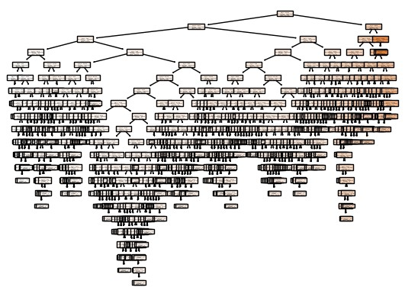

|  |  |  |
| --- | --- | --- |
| **sno** | **Machine Learning Model** | **Mean square error** |
| **1** | **Linear regression** | 2.862281872213113e-25 |
| **2** | **k-nearest neighbour** | 7804.861584840647 |
| **3** | **Decision tree** | 24676.522558139535 |
| **4** | **Support vector machine** | 0.003450724484773055 |

## 8. CONCLUSION AND FUTURE SCOPE

•There are some specific problems in the world that pushes the capability of data science and the technology available in this field to their edge among them one is rainfall predicition

•We can easily conclude that for rainfall prediction this is the best way to use it by forming a range of highest and lowest predicted values by adding bias in the model

•Rainfall prediction main objective is prediction of amount of rain in a specific well or division by using various techinques and finding out which one is best

•Future scope of rainfall prediction

The future scope of rainfall prediction is very promising, with advancements in technology and data analysis techniques. Some of the potential developments in this field include:

•Improvements in Data Collection

•Integration of Big Data

•Advances in Cloud Computing

•Development of Early Warning Systems

•In summary, the future of rainfall prediction looks bright, and with continued research and innovation, we can expect more accurate and reliable predictions that can help people and communities prepare for extreme weather events.

## 9.REFERENCES

[**http://repository.wit.ie/3326/1/InfomationScience_postprint.pdf**](http://repository.wit.ie/3326/1/InfomationScience_postprint.pdf) [**https://www.sciencedirect.com/science/article/pii/S0022030215004932**](https://www.sciencedirect.com/science/article/pii/S0022030215004932) [**https://www.kaggle.com/code/darsh79/starter-rainfall-in-india-99bfc809-4**](https://www.kaggle.com/code/darsh79/starter-rainfall-in-india-99bfc809-4) [**https://www.tandfonline.com/doi/abs/10.4081/ijas.2009.s2.399**](https://www.tandfonline.com/doi/abs/10.4081/ijas.2009.s2.399) [**https://orbi.uliege.be/handle/2268/224000**](https://orbi.uliege.be/handle/2268/224000) [**https://www.sciencedirect.com/science/article/pii/S0022030221005099**](https://www.sciencedirect.com/science/article/pii/S0022030221005099)